

IDH2 (R140Q)
Catalog Number: CR-M26165
Gene Symbol: IDH2; D2HGA2; ICD-M; IDH; IDHM; IDP; IDPM; mNADP-IDH
Description: Anti-IDH2 (R140Q) Mouse Monoclonal Antibody

Background: Isocitrate dehydrogenase (IDH) catalyzes the oxidative decarboxylation of
isocitrate to 2-oxoglutarate. Mutations of
Arg-132 in IDH to Cys, His, Leu or Ser abolish magnesium binding and the conversion of
isocitrate to alpha-ketoglutarate. Instead, alpha-ketoglutarate is converted to
R-2-hydroxyglutarate. Elevated levels of
R-2-hydroxyglutarate are correlated with an elevated risk of malignant brain tumors.
Tested applications: ELISA, WB, IHC Recommended dilutions:
ELISA: 1:1000-1:5000
WB: 1:500-1:1000
IHC: 1:50-1:100
Concentration: 1 mg/ml
Host: Mouse
Clonality: Monoclonal
Purity: Purified from ascites
Format: Liquid Storage buffer:
Preservative: no
Constituents: PBS (without Mg2+ and Ca2+), pH 7.4, 150 mM NaCl, 50% glycerol
Species Reactivity: Recognizes R140Q mutant, but not wild-type IDH2 of vertebrates.
Storage Conditions: Store at -20°C. Avoid freeze / thaw cycles.

Western blot:
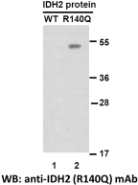
Western blot analysis of recombinant IDH2 (R140Q) and wildtype proteins. Purified
His-tagged IDH2 (R140Q) protein (lane 2) and corresponding wildtype protein (lane 1) were blotted with anti-IDH2 (R140Q) monoclonal
antibody (Cat. #26165).

Immunofluorescence:
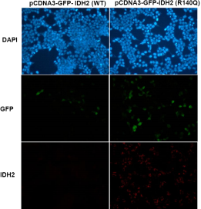
Immunofluorescence of cells expressing IDH2 proteins with anti-IDH2 (R140Q) antibody.
HEK293T cells were transfected with
pCDNA3-GFP-IDH2 (WT) plasmid (left column) or pCDNA3-GFP-IDH2 (R140Q) plasmid (right
column), then fixed and stained with anti-IDH2 (R140Q) monoclonal antibody (Cat. #26165).

